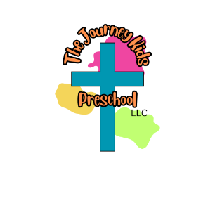
Student Supply List

2s & 3s Class
- Book Bag (fits standard folder)
- 1 box of 24 Crayola crayons
- 8ct Crayola markers
- 4 ct Glue Sticks
- 1in white 3 ring binder
- 1/2in 3 ring binder – any color (3s class only!)
- Water Bottle – leak proof
- 1 pkg of napkins
- 1 box of Kleenex
- 1 container Disinfectant wipes
- 1 ream of white copy paper
- Change of clothes (shirt, pants, socks, underwear)

Early PreK - PreK
- Book Bag (fits standard folder)
- 1 box of 24 Crayola crayons
- 8ct Crayola markers
- 4 ct Glue Sticks
- 12 ct. Pencils
- Pencil Box/Pencil Pouch
- 1in white 3 ring binder
- Water Bottle – leak proof
- 2 rolls of paper towels
- 1 box of kleenex
- 1 ream of colored copy paper
- Paint Shirt (old t-shirt of mom/dad)
- Change of clothes (shirt, pants, socks, underwear)
*Diapers and Wipes if your child is not fully potty trained

Wish List Items 2026 – 2027
Below is a wish list of items that are used by the students and staff throughout the year. If you would like to make a donation of one or more items it would be greatly appreciated.

- Kid Band-aids
- White Cardstock
- Colored Cardstock Paper
- Playdoh
- Googly Eyes (all sizes)
- Baby Wipes
- Sheet Protectors
- Snacks (classes & individual)
- Clorox Disinfecting Wipes
- Laminating Sheets
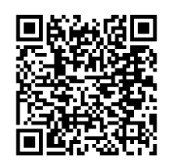
- Amazon Wish List Items

