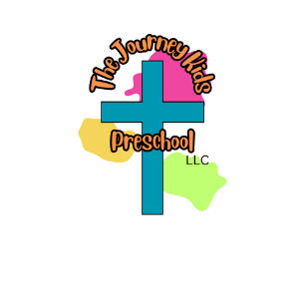
Student Supply List

Monday/Wednesday/Friday Classes
Tuesday/Thursday Classes
- Book Bag (fits standard folder)
- 1 box of 24 Crayola crayons
- 8ct Crayola markers
- 1in white 3 ring binder
- Water Bottle – leak proof
- 1 pkg of napkins
- 2 rolls of paper towels
- 1 box of gallon Ziploc bags (slide)
- 1 box of kleenex
- 1 ream of white copy paper
- Change of clothes (shirt, pants, socks, underwear)
Monday to Friday Classes

- Book Bag (fits standard folder)
- 1 box of 24 Crayola crayons
- 8ct Crayola markers
- 1in white 3 ring binder
- Water Bottle – leak proof
- 1 pkg of napkins
- 2 rolls of paper towels
- 1 box of sandwich Ziploc bags (slide)
- 1 box of kleenex
- 1 ream of colored copy paper
- Change of clothes (shirt, pants, socks, underwear)
*Diapers and Wipes if your child is not fully potty trained

Wish List Items 2025 – 2026
Below is a wish list of items that are used by the students and staff throughout the year. If you would like to make a donation of one or more items it would be greatly appreciated.

- Staples
- 6in and 9in White Paper Plates
- Kid Band-aids
- White Cardstock
- Q-Tips
- Scotch Tape Refills
- Colored Cardstock Paper
- Shaving Cream
- Cotton Balls
- Playdoh
- Kid Bandaids
- Baby Wipes
- Sheet Protectors
- Laminating Sheets
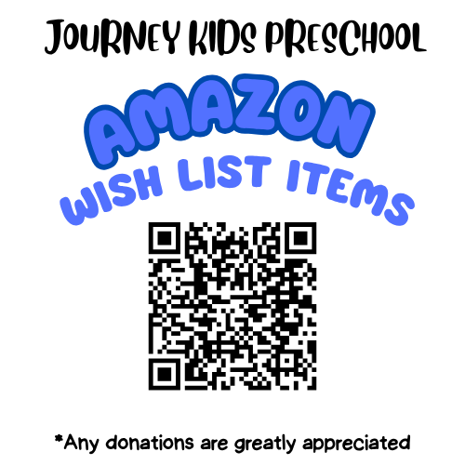
- Amazon Wish List Items

